David Houston

EE 333

Thomas Almy

Oct 28 2014

Lab Assignment 2

# Abstract

This lab focuses on the basics of programming the DragonBoard12. Throughout the lab it was required we add to existing code in an effort to expand our knowledge of the programs workings.

# Introduction

The object of this lab was to create a program which displayed the intensity of light in the room and the ambient air temperature. The following were used in the lab.

* DragonBoard12
* ee333template.asm
* AsmIDE

# Procedure

## Patient 0

For this section of the lab we simply assembled the ee333tempalte.asm file and loaded onto the DragonBoard12 which we then executed. It was noticed that the 4 seven segment displays displayed the work “HELP” the RGB LED was on BLUE and the 8 leds were on in a specific sequence.

## Patient 1

For this section I made a simple program to take values from a light sensor and relay its output to a setup of LEDS in order to tell how much light was hitting it. See Code Part 1 in the appendix. To test the light sensor, I covered it up with my hand and found the value on the leds went down and consequently I shown a light on the sensor and the values violently increased. This was proper assurance that the code was operational.

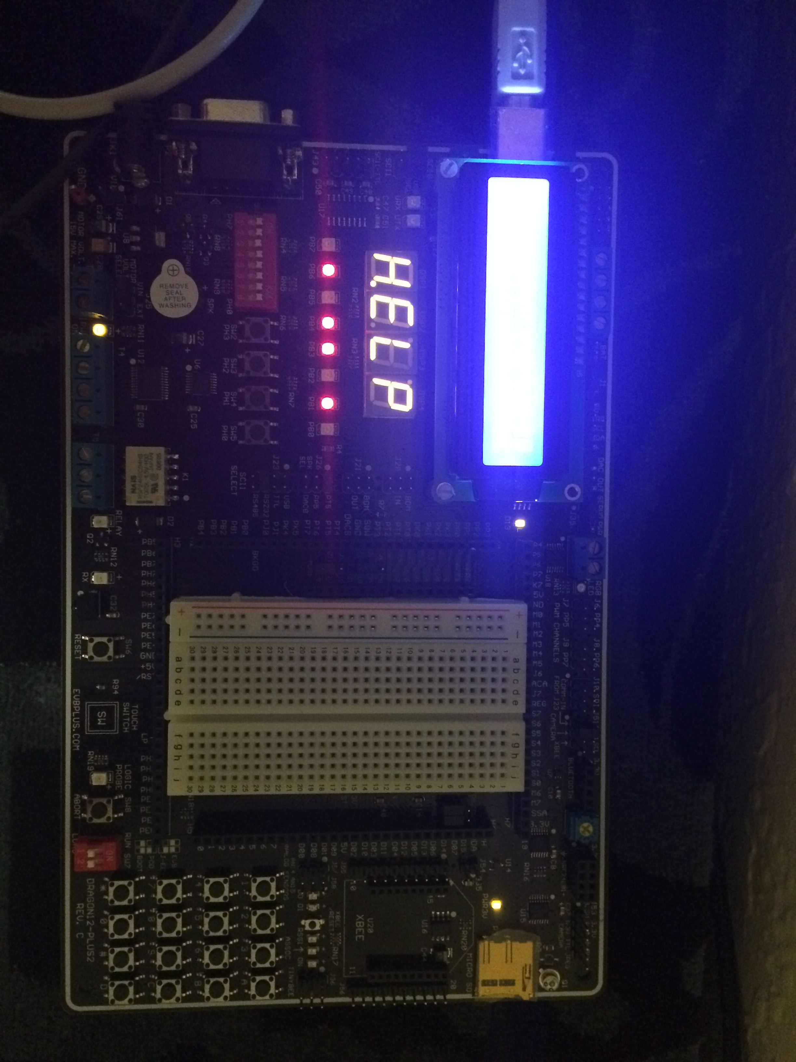

## Patient 2

For our final test and operation of the code we created a program which read the temperature from a thermistor and changed it value and routed it to the 7 seg displays.

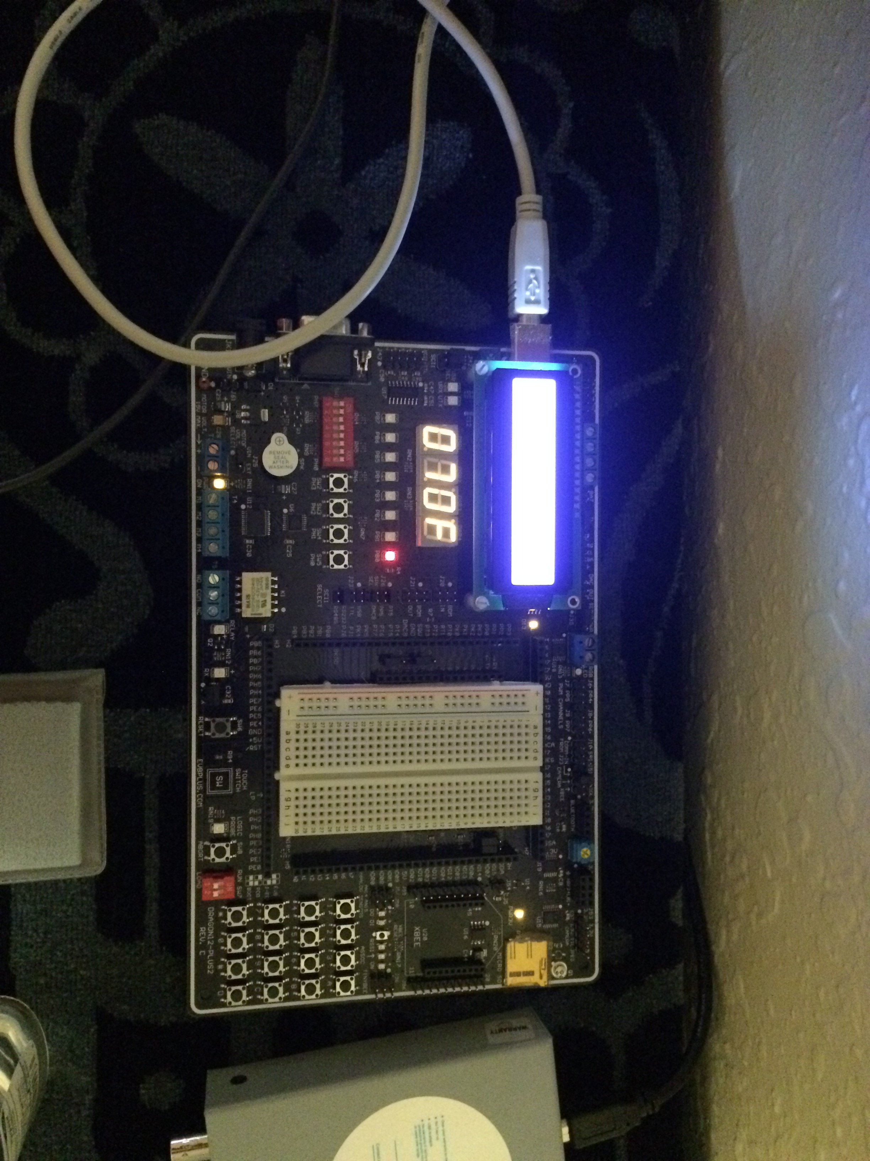

# Analysis

This lab was fun ☺

# Conclusion

That’s all I got.

# Code

## Part 1

ldd ADR04H

lsrd

lsrd

stab displ

## Part 2

ldd ADR05H

ldy #900

emul

ldx #1023

ediv

leay 32,y

tfr Y D

ldy #disptn

leay 2,Y

conv: ldx #10

idiv

stab 1,Y-

tfr X D

cpy #disptn

blo ending

bra conv

ending: movb #15 4,Y